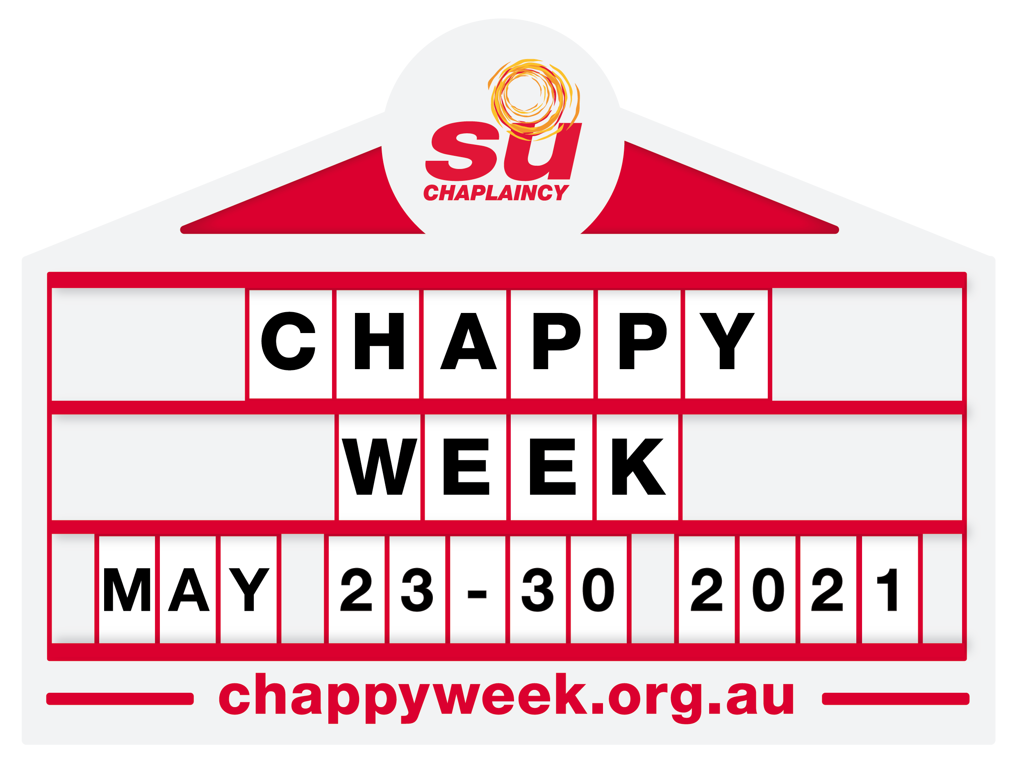

Tuck into ‘Chappy Hour’ at McDonald’s

[Insert date]

What is Chappy Week?
Chappy Week is an annual community awareness and fundraising event for school chaplaincy.
- May 23 – 30, 2021
- Held in about 900 primary and high schools and communities state-wide
- Supported and endorsed by various local governments, community leaders and business groups (including The Coffee Club and McDonald’s in previous years)
- High levels of community engagement and positive media exposure for The Coffee Club
  - Promotion of corporate partnerships in local schools
  - Potential for positive television coverage
  - Numerous ‘Chappy Week’ articles published in dozens of local news outlets and radio stations across Queensland
  - Features in SU QLD’s communications and social media channels, with a potential audience of more than 17,000 regular supporters
How McDonald’s can get involved
McDonald’s already has a strong reputation for community support and Chappy Week provides an excellent opportunity to reach into school communities directly.
‘Chappy Hour’
In previous years, chaplains have teamed up with their local McDonald’s to run a ‘Chappy Hour’ between 3.30pm and 4.30pm. Specific deals, proceeds and promotions can be negotiated between each chaplain and their local franchisee.

Who is SU QLD?
Scripture Union Queensland (SU QLD) is officially endorsed by Education Queensland as an accredited employing authority of school chaplains. There are approximately 600 SU QLD school chaplains employed in Queensland schools in more than 900 state schools. School chaplains rely on vital community support and funding.

Contact details: [Insert Chaplain’s contact details here]

